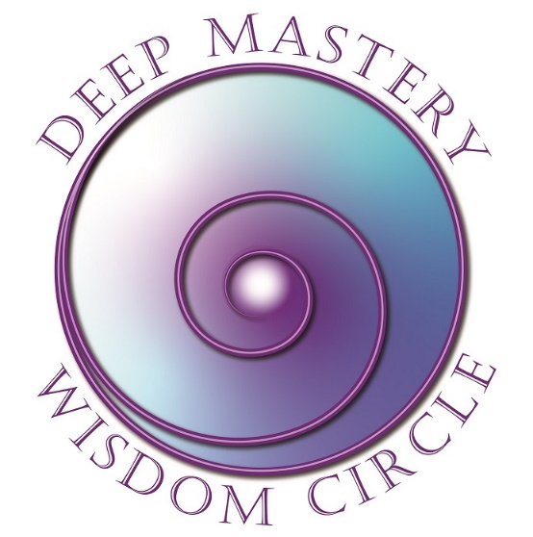

Registration
Yes! I want to register for Deep Mastery Wisdom Circle!
Dates: January 10, 24; Feb 7, 21; March 6, 20, April 3, 17; May 1, 15

Wednesdays: 8-9:30 PT, 9-10:30 MT, 10-11:30 CT, 11-12:30 ET, 17-18:30 CET

Please complete this 2-page form and mail or scan and email.

General Information
Name
Address
City |  | State/Province |  |  | Zip
Email |  |  | Phone |  | ( )
Payment Information

Program Fee: $1,350 USD paid in full in advance
Early Bird Discount: $1,150 paid in full before December 1, 2023
Cancel two weeks prior to the class starting to receive full refund less $250 administrative fee.

Check: | Make checks payable to FJFisher Coaching and Consulting  address below  Or:
PayPal: | Make your payment (in full or deposit) to MY PayPal account at: Fran@FranFisherCoach.com

Outcomes Desired:

What attracted you to this Program?
__________________________________________________________________________________________________________________________________________________________________________________________

What are you intending to experience/accomplish out of participating in this course?
__________________________________________________________________________________________________________________________________________________________________________________________

What other personal growth/experiential courses have you attended?
__________________________________________________________________________________________________________________________________________________________________________________________

Thank you for taking time to complete this form. This information will help me serve you better.

Fran Fisher, MCC
FJFisher Coaching and Consulting | Office Phone: +1 (970) 833-5447
2004 Rivers Edge Road | Text: (425) 753-6074
Windsor, CO 80550 | Email: Fran@FranFisherCoach.com

