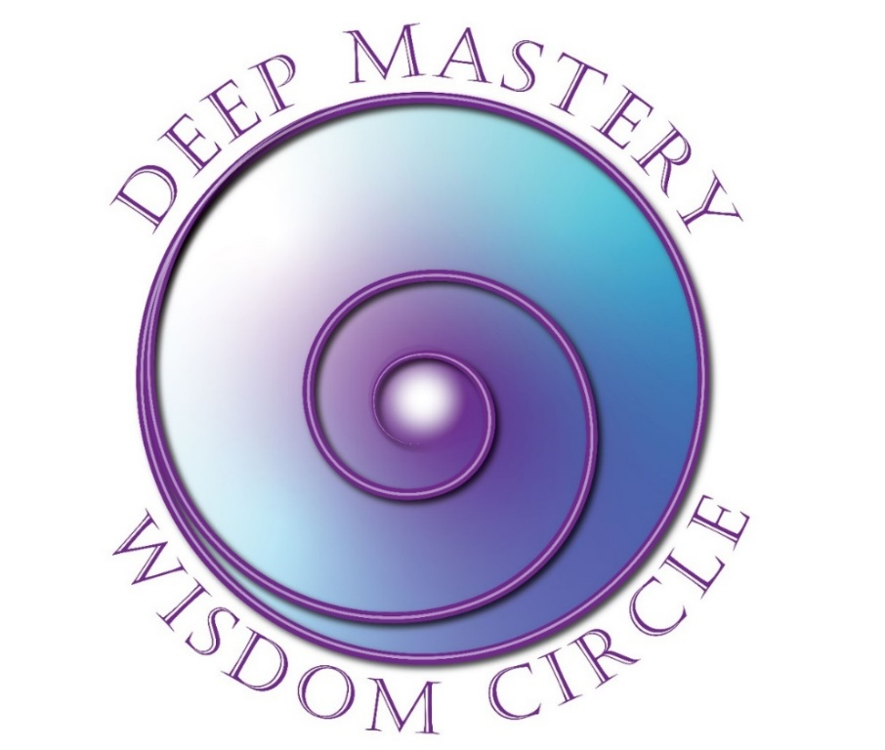

Registration
First Quarter 2026
Dates and Times: TBD

NOTE: Please reach out to Fran directly at fran@franfishercoach.com to learn more
about DMWC and the next program planned for First Quarter, 2026

Yes! I want to register for Deep Mastery Wisdom Circle!

Please complete this 2-page form and mail or email it to Fran at the address on the next page.

Participant Information
Name
Address
City |  | State/Province |  | Zip
Email |  |  | Phone | ( )
Website

Payment Information
Program Fee: | $1,800 USD paid in full in advance
Early Bird Discount: | $1,600 paid in full one month prior to class start date
Cancellation | Cancel two weeks prior to the class start to receive full refund less $250 administrative fee.
Payment Method: | PayPal
 | Make your payment (in full or deposit) to Fran’s PayPal account: fran@franfisherfoach.com

Outcomes Desired
What attracted you to this program?
__________________________________________________________________________________________________________________________________________________________________________________________

What are you intending to experience/accomplish out of participating in this course?
__________________________________________________________________________________________________________________________________________________________________________________________

What other personal growth/experiential courses have you attended?
__________________________________________________________________________________________________________________________________________________________________________________________

Thank you for taking the time to complete this form.
This information will help me serve you better.

Fran Fisher, MCC
FJFisher Coaching and Consulting
(425) 753-6074 (Mountain Time)
Email: fran@franfisherfoach.com
Website: www.FranFisherCoach.com

