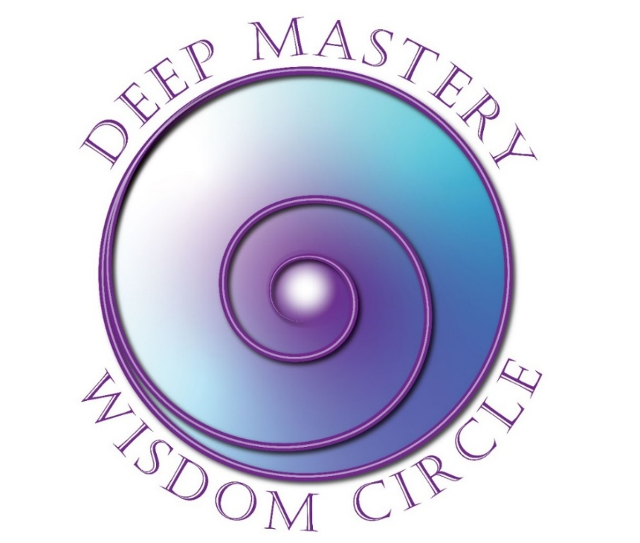

Registration
February 18 – June 17, 2026

Wednesdays Bi-Weekly: 8:00-9:30 PT/11:00-12:30 ET
Dates: Feb 18; Mar 4, 18; April 1, 15, 29; May 6, 20; June 3, 17

Yes! I want to register for Deep Mastery Wisdom Circle!

Please complete this 2-page form and email it to Fran at the email address on the next page.

Participant Information
Name
Address
City |  | State/Province |  | Zip
Email |  |  | Phone | ( )
Website

Payment Information
Program Fee: | $1,800 USD paid in full in advance
Early Bird Discount: | $1,600 paid in full before January 1, 2026
Cancellation | Cancel two weeks prior to the class start to receive full refund less $250 administrative fee.
Payment Method:
PayPal: | Make your payment (in full or deposit) to my PayPal account Fran@FranFisherCoach.com or reach out to me directly if you need to use a different payment method.

Outcomes Desired
What attracted you to this program?
__________________________________________________________________________________________________________________________________________________________________________________________

What are you intending to experience/accomplish out of participating in this course?
__________________________________________________________________________________________________________________________________________________________________________________________

What other personal growth/experiential courses have you attended?
__________________________________________________________________________________________________________________________________________________________________________________________

Thank you for taking the time to complete this form.
This information will help me serve you better.

Fran Fisher, MCC
FJFisher Coaching and Consulting
(425) 753-6074
Fran@FranFisherCoach.com

