Inspiring Competence

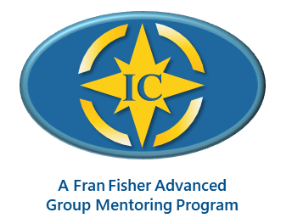

Enhancing Your Presence and Power to Call Forth Your Client’s Greatness

Facilitated by Annie Gelfand, MCC

Mentoring with Fran Fisher MCC, Annie Gelfand MCC, and Diana Ideus MCC

Registration Form

Next Available Program: February − June 2026
TUESDAYS: 11:00 AM to 12:30 PM (ET)
Feb 3 (orientation), 17; Mar 3, 17, 31; Apr 14, 28; May 12, 26; Jun 9, 23

Please complete this 2-page form, scan, and send it to my email address listed on the following page.

General Information
Name
Address
City |  | State | Zip
Phone | ( ) | Email
Website

Payment Information
Program Fee: | $2,950 USD  Early Bird Discount: $2,750 paid in full before December 15, 2025
Payment: | Please make your payment(s) (in full or $500 deposit) to my PayPal account: fran@franfishercoach.com

Coach Training Courses or Programs I Have Attended:

Current Coaching Experience:
# of Hours Coaching Experience to Date:
# of Coaching Clients Now:
ICF Credential Being Sought: PCC_________ MCC __________

Outcomes Desired:
What attracted you to this course? ____________________________________________________
What are you intending to experience out of taking this course?

Your Learning and Feedback Preferences:
What style or approach works best for you regarding feedback and suggestions?

When you feel challenged, what is one approach you take to stay on track toward your intended outcome?
What gets in your way regarding hearing feedback and suggestions?

What might you need more of or less of from your mentor coach?

Thank you for taking time to complete this form. This information helps me serve you better. If you want more details about my Inspiring Competencies group program, feel free to email me.

Fran Fisher, MCC
FJFisher Coaching and Consulting
Mobile: +1-425-753-6074 Email: fran@franfishercoach.com

