Inspiring Competence
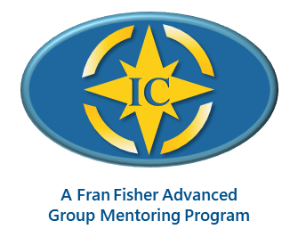

Enhancing Your Presence and Power
to Call Forth Your Client’s Greatness

Facilitated by Annie Gelfand, MCC, MCS


Mentoring with Fran Fisher MCC, MCS, and Annie Gelfand MCC, MCS

Registration Form

Next Available Program: January − June, 2027
TUESDAYS: 11:00 AM to 12:30 PM (ET)
Jan 26 (orientation), Feb 9; 23; March 9, 23; April 6, 20; May 4, 18; June 1, 15

Payment Information
Program Fee: | $2,950 USD paid in advance  Early Bird Discount: $2,750 paid before December 15, 2026
Payment: | To reserve your space, make a $500 deposit using the following link: https://essenceofmastery.thrivecart.com/ic-group-deposit-500  To pay in full or in three installments, make your payment using the following link: https://essenceofmastery.thrivecart.com/ic-group-mentoring/  Cancellation: Two weeks prior to the class start to receive a full refund minus a $300 administrative fee

Please complete the following information, scan, and send it to: Annie@radicalwisdom.com.
General Information
Name
Address
City |  | State | Zip
Phone | ( ) | Email
Website

Coach Training Courses or Programs I Have Attended:

Current Coaching Experience:
Number of coaching hours of experience to date:
Number of coaching clients now:
ICF credential being sought: PCC_________ MCC __________

Outcomes Desired:
What attracted you to this course? ____________________________________________________
What are you intending to experience as a result of taking this course?

Your Learning and Feedback Preferences:
What style or approach works best for you regarding feedback and suggestions?

When you feel challenged, what is one approach you take to stay on track toward your intended outcome?
What gets in your way regarding hearing feedback and suggestions?

What might you need more of or less of from your mentor coach?

Thank you for taking time to complete this form. This information helps us serve you better. If you want more details, please email me at annie@radicalwisdom.com.

Annie Gelfand, MBA, MCC, MCS
Mobile: +1-416-246-2697 Email: annie@radicalwisdom.com

